MINOR PROJECT
UNDERSTANDING DNA DAMAGE AND REPAIR

HUTCHINSON-GILFORD PROGERIA SYNDROME (HGPS)

Hutchinson-Gilford Progeria Syndrome is an extremely rare genetic disorder caused by a spontaneous mutation in the LMNA gene, which produces a defective protein that causes cells to age rapidly. Affected children appear healthy at birth but quickly develop physical signs of advanced aging, including hair loss and joint stiffness. Because the cell damage severely impacts the cardiovascular system, most children with the condition succumb to early heart attacks or strokes in their mid-teens.

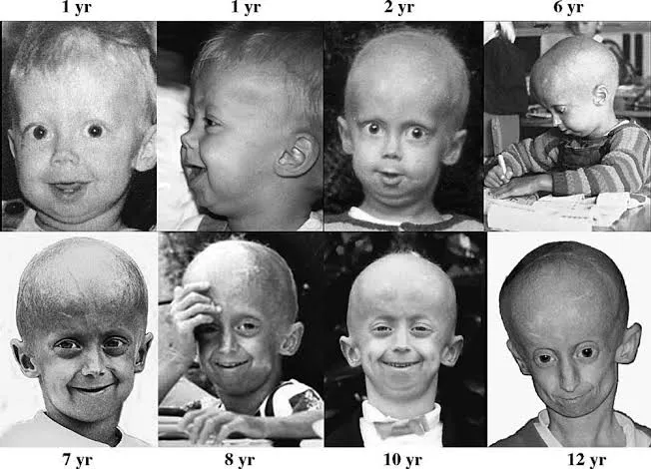
https://docquity.com/articles/about-hutchinson-gilford-progeria-syndrome

The gene involved is LMNA ( Lamin A/C gene ). This gene is normally present on the chromosome 1q22. This LMNA gene normally provides instructions for making structural proteins called Lamin A and Lamin C. Lamin A forms the nuclear lamina, a dense meshwork of proteins located just inside the inner membrane of the cell nucleus. It provides structural support, shape, and stability to the cell nucleus. It helps organize chromatin (DNA), regulates gene expression, plays a role in DNA repair mechanisms, and assists in proper cell division.https://pmc.ncbi.nlm.nih.gov/articles/PMC6406247/

A mutation is a change in the DNA sequence of a cell. It can happen when DNA is copied incorrectly during cell division or due to environmental factors. Mutations can alter how proteins are made, affecting body functions.
LMNA change is technically a silent mutation at protein code level because it still codes for same amino acid (glycine ). However, it accidentally creates a "cut site" (cryptic donor splice site) in the RNA. During processing, the cell trims away 50 amino acids by mistake. This yields a defective, shortened version of the structural protein lamin A, known as progerin which damages cell nuclei and leads to rapid premature aging.
This occurs at LMNA gene (which normally provides instructions for nuclear frame proteins). Chromosome 1 (at location 1q22), Exon 11, Position 1824 of the DNA sequence (Codon 608).
https://www.ncbi.nlm.nih.gov/books/NBK1121

The effect on protein is explained in the following table :
DNA change | c.1824C>T point mutation in Exon 11 of the LMNA gene.
RNA change | Activates a hidden donor splice site, deleting 150 bases from the mRNA.
Protein change | Produces Progerin, an altered Lamin A protein missing 50 amino acids.
Protein function change | Progerin retains a sticky lipid tag (farnesyl group), forcing it to stay trapped in the nuclear membrane. This deforms the nucleus, causes DNA damage, and leads to rapid premature cell death.

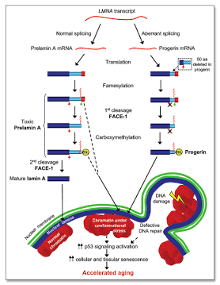
https://www.researchgate.net/figure/Molecular-mechanisms-underlying-immature-lamin-A-induced-progeria-Transcription-from-a_fig1_7509274

This flowchart shows the molecular pathway of HGPS :
[ c.1824C>T Point Mutation in Exon 11 of LMNA Gene ] (Gly608Gly / Silent/De Novo)
│
▼
[ Activation of Cryptic Splice Site in Pre-mRNA ]
│
▼
[ Aberrant Splicing / 50-Amino Acid Deletion (Δ50) in Prelamin A ]
│
▼
[ Translation of Progerin ] (Lacks ZMPSTE24 Endoproteolytic Cleavage Site)
│
▼
[ Permanent C-Terminal Farnesylation & Methylation ]
│
▼
[ Tightly Anchored to Inner Nuclear Membrane ]
│
▼
[ Disruption of Nuclear Architecture & Function ]
┌─────────────┼─────────────┬─────────────┐
▼ ▼ ▼ ▼
[ Nuclear [ Loss of [ Defective [ Accelerated
Blebbing & Hetero- DNA Damage Telomere
Instability ] chromatin ] Response ] Attrition ]
│ │ │ │
└─────────────┼─────────────┴─────────────┘
│
▼
[ Cellular Senescence & Premature Aging Phenotypes (Cardiovascular Failure) ]

Lamin A forms the internal scaffold (nuclear lamina) supporting the nucleus. Progerin stays anchored to the nuclear membrane, distorting the nuclear shape into misshapen, wrinkled structures. Progerin disrupts the normal anchoring of replication machinery during cell division. This causes the replication forks to stall and collapse, converting normal single-stranded DNA into lethal DNA Double-Strand Breaks (DSBs). Progerin traps key repair proteins (like 53BP1, Rad50, and Rad51) and prevents them from properly reaching damaged sites. HGPS cells produce excess Reactive Oxygen Species (ROS), which attack DNA bases directly, leading to constant chemical damage.

Without repair, accumulated DNA damage triggers severe cellular consequences:
Unrepaired DSBs activate persistent ATM/ATR kinase signals, forcing cells into permanent arrest (premature aging). High lesion loads cause programmed cell death, depleting tissue stem cells and causing tissue atrophy. Chromosomal translocations, deletions, and loss of genetic blueprints occur.
In Hutchinson-Gilford Progeria Syndrome (HGPS), Non-Homologous End Joining (NHEJ) is the primary double-strand break repair pathway utilized by cells.
While NHEJ is active, it does not function properly due to the presence of progerin. The exact mechanics of how DNA repair operates in HGPS involve several factors:
Progerin causes severe nuclear membrane deformity and disrupts normal chromatin structure, leading to an accumulation of DNA double-strand breaks (DSBs). Because NHEJ operates throughout all stages of the cell cycle (unlike HR, which requires the cell to be dividing), HGPS cells default to NHEJ to rejoin these breaks. High-fidelity, error-free repair (HR) is severely suppressed in HGPS cells.
Progerin sequesters critical HR recruitment proteins (like Rad51 and BRCA1), preventing cells from executing template-based repair during replication. This forces the cell to rely almost entirely on defective NHEJ. https://pmc.ncbi.nlm.nih.gov/articles/PMC11244969

Maintaining DNA integrity ensures that the correct gene sequence is preserved, which provides the precise instructions required to produce functional protein structures. In HGPS, a point mutation in the LMNA gene produces the toxic, truncated progerin protein, which disrupts normal cellular function by impairing nuclear architecture, stalling replication forks, and inducing double strand DNA breaks. This ongoing cellular stress directly drives the severe premature aging phenotype characteristic of progeria. Efficient DNA repair is essential to counteract this genomic instability, preventing the accumulation of persistent DNA damage that leads to premature cellular senescence and cell death. Ultimately protecting genome stability through robust DNA repair mechanisms is critical for maintaining nuclear integrity preserving tissue homeostasis and mitigating the systemic vascular and physical decline seen in HGPS.

